***Human Biology ATAR – Task 2:* End of term test**

***Content covered weeks 1-9 (5%)***

|  |  |  |  |
| --- | --- | --- | --- |
| Name: | | | |
| Time allowed: 55 Minutes + 5 minutes reading time | | | |
| **Section** | Your Mark | Marks available | Percentage of Test |
| **Multiple Choice (A)** |  | 15 | 25% |
| **Short Answer (B)** |  | 35 | 58% |
| **Extended Response (C)** |  | 10 | 17% |
|  |  | **60** | **100%** |

**Declaration of Authenticity**

I (Student Name) _____________________ declare that this work is my own and I have not plagiarised from any source.

Signature:  
  
Date:

***Section A – Multiple Choice (15 marks)***

1. The mitochondria:
   1. give rise to the endoplasmic reticulum
   2. are usually doubled-layered organisms with finger like extensions
   3. are the centre of RNA synthesis
   4. are the centres of cellular respiration
2. Lysosomes are thought to be concerned with:
   1. digestion of cell material
   2. production of energy
   3. passing in of genes
   4. secretion of materials
3. Cell membranes are generally composed of:
   1. A double layer of phospholipids and cholesterol with proteins dispersed throughout the membrane
   2. A double layer of phosphoproteins with glucose dispersed throughout the membrane
   3. A double layer of nucleic acids
   4. A double layer of proteins with phospholipids dispersed throughout the membrane
4. The type of tissue that is responsible for covering the outside of organs such as the kidney and liver, and lining the inside of organs such as the stomach and intestines is the:
5. Connective Tissue
6. Epithelial Tissue
7. Muscular Tissue
8. Nervous Tissue
9. Anabolism can be defined as:
10. reactions in which small molecules are built up to form large molecules and release energy
11. reactions in which small molecules are built up to form large molecules and require energy
12. reactions in which large molecules are broken down to smaller molecules and release energy
13. reactions in which large molecules are broken down to smaller molecules and require energy

Question 6 refers to the below diagram representing osmosis:

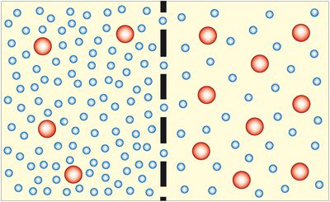

Large solute

 Water molecule

1. Which of the following situations would occur?
2. Overall the solute would travel through the membrane from right to left
3. Overall the water would travel through the membrane from left to right
4. The water will travel in both directions across the membrane equally
5. Overall the solute will travel through the membrane from right to left and the water from right to left
6. How are ADP and ATP related?
7. they are identical except ADP has more energy
8. ADP has one more phosphate group and less stored energy that ATP
9. they are opposite processes
10. ATP has one more phosphate group and more stored energy than ADP
11. In facilitated diffusion:
    1. transport is quicker than normal diffusion
    2. transport is selective
    3. transport of one substance is stopped by another
    4. all of the above
12. A protein is made up of:
    1. simple sugars
    2. fatty acid
    3. glycerol
    4. amino acids
13. Erythrocytes mainly carry:
    1. oxygen
    2. carbon dioxide
    3. oxygen and carbon dioxide
    4. oxygen and nitrogen
14. Referring to the blood vessels, which statement is always true?
15. arteries carry deoxygenated blood, veins carry oxygenated blood
16. arteries carry oxygenated blood, veins carry deoxygenated blood
17. arteries carry blood towards the heart, veins carry blood away from the heart
18. arteries carry blood away from the heart, veins carry blood towards the heart

Question 12 refers the diagram below:

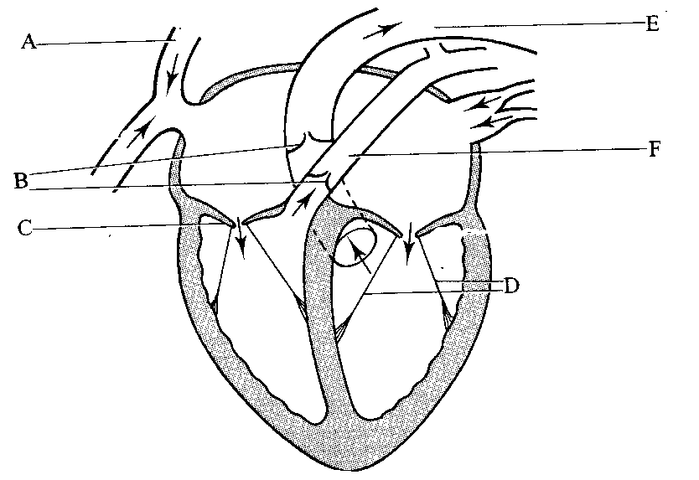

1. The part of the heart labelled A is the
   1. aorta
   2. superior vena cave
   3. semi lunar valve
   4. left atrium
2. What is the function of the structure labelled F?
   1. to carry blood from the body into the right atrium
   2. to carry blood from the right ventricle to the lungs
   3. to carry blood from the lungs to the right ventricle
   4. to carry blood from the body into the left atrium
3. The type of tissue that would most likely contain the highest number of mitochondria is:
   1. muscle tissue
   2. nervous tissue
   3. epithelial tissue
   4. connective tissue

Question 15 refers to the diagram below:

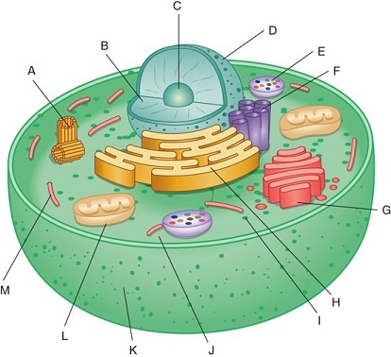

1. The part labelled with the letter E is a:
   1. mitochondrion.
   2. lysosome.
   3. microtubule.
   4. centriole.

**END OF MULTIPLE CHOICE**

***Section B – Short Answer (35 marks)***

1. The following graph shows the results of an experiment involving the breakdown of starch by an enzyme. **[4 marks]**

**Effect of temperature on breakdown of starch by an enzyme**

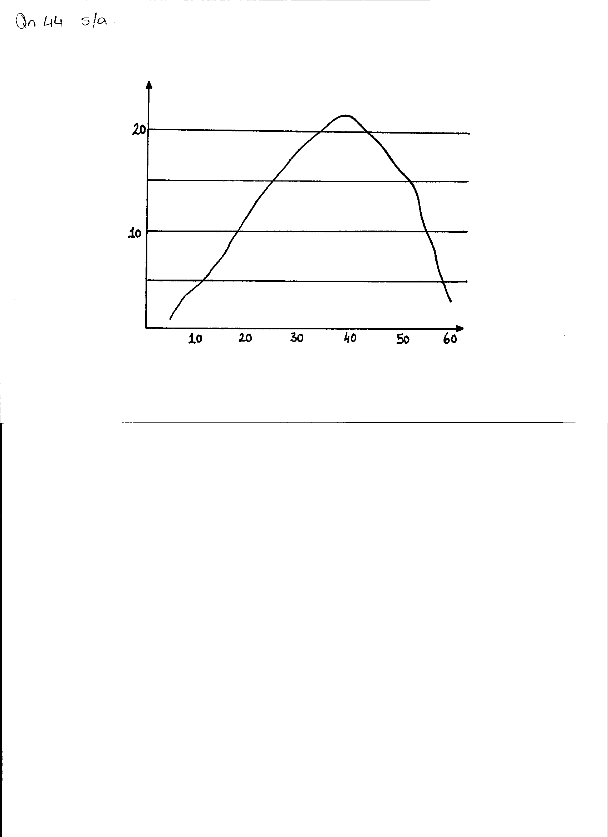

**Enzyme activity in mg of starch broken**

**Temperature in OC**

1. State the optimum temperature for the activity of this enzyme. **(1 mark)**

_____________________________________________________________________________

1. State the reason why the rate of reaction drops rapidly at temperatures above 45OC. **(1 mark)**

______________________________________________________________________________________

______________________________________________________________________________________

1. Name the end product formed from the digestion of starch.  **(1 mark)**

_____________________________________________________________________________

1. State **ONE** factor, other than temperature, which affects the activity of an enzyme **(1 mark)**

_____________________________________________________________________________

1. Use this diagram of the heart to answer the following questions: **[13 marks]**

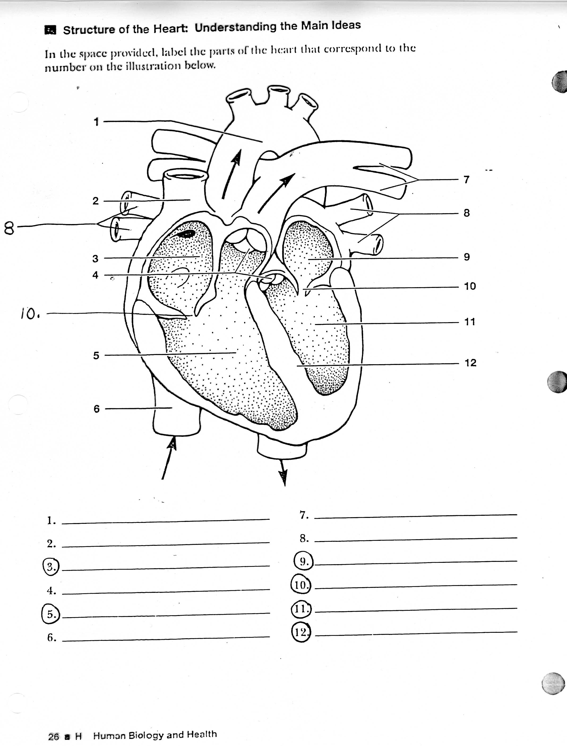

1. Identify the following structures: **(2 marks)**
2. structure 10 _______________________________
3. structure 4 _______________________________
4. Explain the function the above structures have in common **(3 marks)**

___________________________________________________________________________

___________________________________________________________________________

___________________________________________________________________________

___________________________________________________________________________

1. Which chamber of the heart does the greatest work? Give evidence to support **(3 marks)**

___________________________________________________________________________

___________________________________________________________________________

___________________________________________________________________________

___________________________________________________________________________

1. Define Cardiac output and include the formula to solve for C.O. **(2 marks)**

­_______________________________________________________________________________

_______________________________________________________________________________

_______________________________________________________________________________

1. Label the following structures **(3 marks)**
2. 7 __________________________
3. 12 __________________________
4. 6 __________________________
5. Explain the following processes, where they occur in the cell and the amount of energy each process yields **[6 marks]**
6. Aerobic respiration **(3 marks)**

________________________________________________________________________

________________________________________________________________________

________________________________________________________________________

___________________________________________________­­­­­­­­­­­­­­­­­­­­­­­_____________________

________________________________________________________________________

1. Anaerobic respiration **(3 marks)**

________________________________________________________________________

________________________________________________________________________

________________________________________________________________________

___________________________________________________­­­­­­­­­­­­­­­­­­­­­­­_____________________

________________________________________________________________________

1. Blood is composed of plasma and formed elements. List the three types of formed elements in the table below and give ONE function of each. **[6 marks]**

|  |  |
| --- | --- |
| **BLOOD COMPONENT** | **FUNCTION** |
|  |  |
|  |  |
|  |  |

1. Label the structures in the diagram below, by writing the name next to the matching letter in the table **[6 marks]**

|  |  |
| --- | --- |
| **STRUCTURE** | **NAME** |
| A1 |  |
| A2 |  |
| C |  |
| E |  |
| G |  |
| H-I |  |

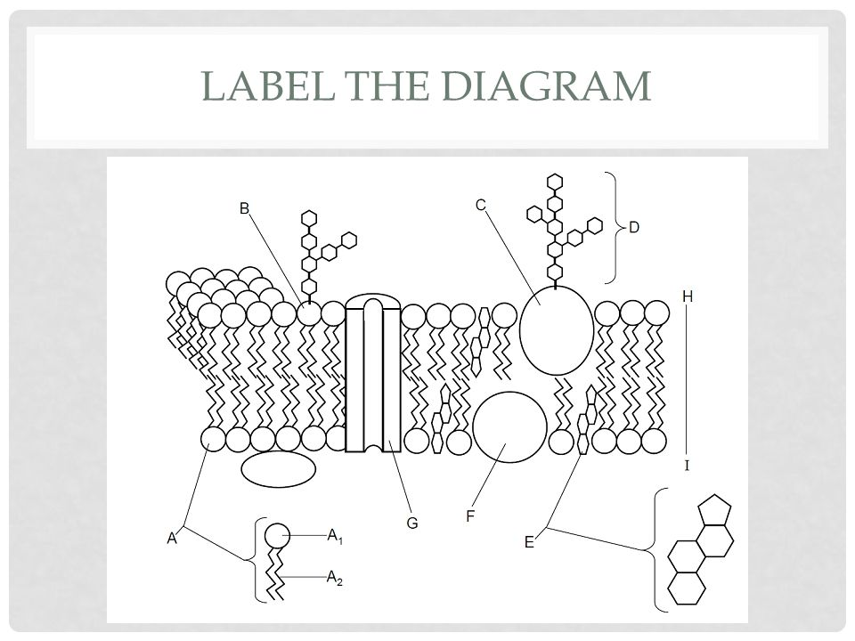

**END OF SECTION B**

***Section C – Extended Response***

1. Explain how oxygen and carbon dioxide are transported in the blood. Your answer should explain the different ways they are transported (include comparative amounts and percentages).

**(10 marks)**

___________________________________________________________________________

___________________________________________________________________________

___________________________________________________________________________

___________________________________________________________________________

___________________________________________________________________________

___________________________________________________________________________

___________________________________________________________________________

___________________________________________________________________________

___________________________________________________________________________

___________________________________________________________________________

___________________________________________________________________________

___________________________________________________________________________

___________________________________________________________________________

___________________________________________________________________________

___________________________________________________________________________

___________________________________________________________________________

___________________________________________________________________________

___________________________________________________________________________

___________________________________________________________________________

___________________________________________________________________________

___________________________________________________________________________

___________________________________________________________________________

___________________________________________________________________________

___________________________________________________________________________

___________________________________________________________________________

___________________________________________________________________________

___________________________________________________________________________

___________________________________________________________________________

___________________________________________________________________________

___________________________________________________________________________

___________________________________________________________________________

___________________________________________________________________________

___________________________________________________________________________

___________________________________________________________________________

___________________________________________________________________________

___________________________________________________________________________

___________________________________________________________________________

___________________________________________________________________________

___________________________________________________________________________

___________________________________________________________________________

___________________________________________________________________________

___________________________________________________________________________

___________________________________________________________________________

___________________________________________________________________________

___________________________________________________________________________

___________________________________________________________________________

___________________________________________________________________________

___________________________________________________________________________

___________________________________________________________________________

___________________________________________________________________________

___________________________________________________________________________

___________________________________________________________________________

___________________________________________________________________________

___________________________________________________________________________

___________________________________________________________________________

___________________________________________________________________________

*­­­­­­­­­­­­­­­­­­­­­­*

**END OF TEST**